**Chapter 4:**

**Introduction to Differential Equations**

**4.4 The Logistic Equation**

**Section Exercises**

**For the following problems, consider the logistic equation in the form  Draw the directional field and find the stability of the equilibria.**

169. 

Answer:

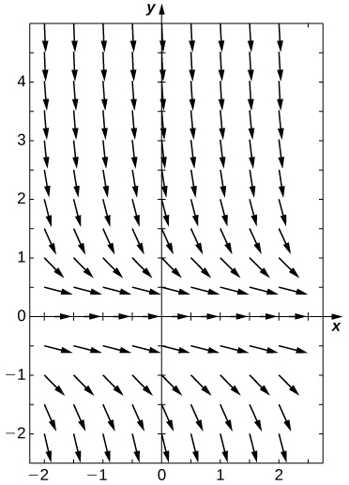

semi-stable

171. Solve the logistic equation for and an initial condition of 

Answer: 

173. A population of deer inside a park has a carrying capacity of  and a growth rate of. If the initial population is deer, what is the population of deer at any given time?

Answer:

175. **[T]** Bacteria grow at a rate of  per hour in a petri dish. If there is initially one bacterium and a carrying capacity of  million cells, how long does it take to reach cells?

Answer: hoursminutes

177. **[T]** Two monkeys are placed on an island. After  years, there are  monkeys, and the estimated carrying capacity is monkeys. When does the population of monkeys reach monkeys?

Answer: yearsmonths

**The following problems consider the logistic equation with an added term for depletion, either through death or emigration.**

179. **[T]** The population of trout in a pond is given by where trout are caught per year. Use your calculator or computer software to draw a directional field and draw a few sample solutions. What do you expect for the behavior?

Answer:

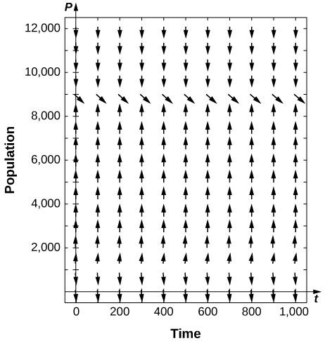

181. **[T]** For the preceding problem, use software to generate a directional field for the value What are the stabilities of the equilibria?

Answer:

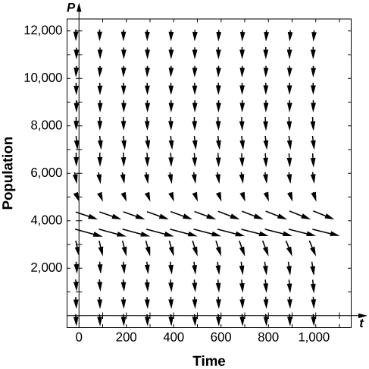

semi-stable

183. **[T]** For the preceding problems, consider the case where a certain number of fish are added to the pond, or What are the nonnegative equilibria and their stabilities?

Answer:

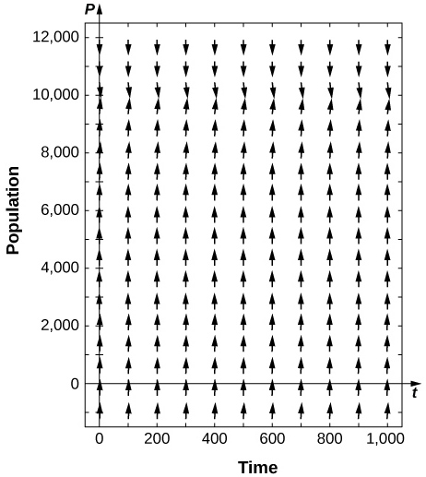

stable

**It is more likely that the amount of fishing is governed by the current number of fish present, so instead of a constant number of fish being caught, the rate is proportional to the current number of fish present, with proportionality constant as**

185. **[T]** Use software or a calculator to draw directional fields forWhat are the nonnegative equilibria and their stabilities?

Answer:

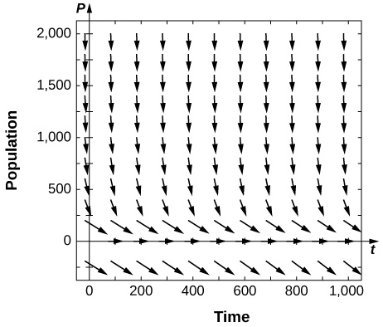

is semi-stable

187. Solve this equation, assuming a value ofand an initial condition of  fish.

Answer: 

**The following problems add in a minimal threshold value for the species to survive, which changes the differential equation to**

189. Draw the directional field of the threshold logistic equation, assuming When does the population survive? When does it go extinct?

Answer:

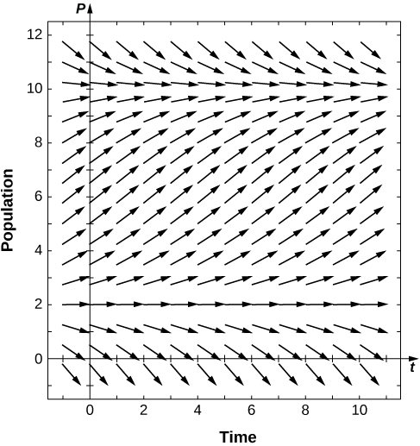

191. Bengal tigers in a conservation park have a carrying capacity of  and need a minimum of  to survive. If they grow in population at a rate of  per year, with an initial population of tigers, solve for the number of tigers present.

Answer: 

193. The population of mountain lions in Northern Arizona has an estimated carrying capacity of and grows at a rate of per year and there must be  for the population to survive. With an initial population of  mountain lions, how many years will it take to get the mountain lions off the endangered species list (at least)?

Answer: years months

**The following questions consider the, a modification for logistic growth, which is often used for modeling cancer growth, specifically the number of tumor cells.**

195. Assume that for a population,and Draw the directional field associated with this differential equation and draw a few solutions. What is the behavior of the population?

Answer:

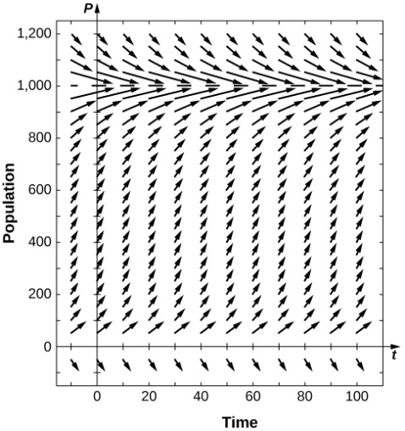

197. **[T]** The Gompertz equation has been used to model tumor growth in the human body. Starting from one tumor cell on dayand assumingand a carrying capacity of million cells, how long does it take to reach “detection” stage at million cells?

Answer:days

199. [**T]** It is estimated that the world human population reached  billion people in and billion in Assuming a carrying capacity of billion humans, write and solve the differential equation for Gompertz growth, and determine what year the population reached billion. Was logistic growth or Gompertz growth more accurate, considering world population reached billion on October

Answer: September

201. When does population increase the fastest in the threshold logistic equation

Answer: 

**Below is a table of the populations of whooping cranes in the wild fromThe population rebounded from near extinction after conservation efforts began. The following problems consider applying population models to fit the data. Assume a carrying capacity of cranes. Fit the data assuming years since  (so your initial population at time  would be  cranes).**

|  |  |
| --- | --- |
| Year (years since conservation began) | Whooping Crane Population |
|  |  |
|  |  |
|  |  |
|  |  |
|  |  |
|  |  |
|  |  |

203. Find the equation and parameter  that best fit the data for the logistic equation.

Answer: 

205. Find the equation and parameter that best fit the data for the Gompertz equation.

Answer: 

207. Using the three equations found in the previous problems, estimate the population in  (year  after conservation). The real population measured at that time was. Which model is most accurate?

Answer: Logistic:Threshold:Gompertz:

**Student Project**

**Logistic Equation with a Threshold Population**

1. The threshold population is useful to biologists and can be utilized to determine whether a given species should be placed on the endangered list. A group of Australian researchers say they have determined the threshold population for any species to survive:  adults. Therefore, we use  as the threshold population in this project. Suppose that the environmental carrying capacity in Montana for elk is  Set up  using the carrying capacity of  and threshold population of  Assume an annual net growth rate of 

Answer: 

3. What is the limiting population for each initial population you chose in step? (Hint: use the slope field to see what happens for various initial populations, i.e., look for the horizontal asymptotes of your solutions.)

Answer: If  then the limiting population is 25000. If then the limiting population is 5000. If then the limiting population is 0.

This file is copyright 2016, Rice University. All Rights Reserved.